**AIM:** Write a C program to implement Queue operations such as ENQUEUE, DEQUEUE

**ALGORITHM:**

1. **Start**
2. **Initialize**: front = -1, rear = -1.
3. **ENQUEUE (Insert element at rear)**
   * If rear == MAX-1 → Queue Overflow.
   * Else if front == -1 → set front = 0, increment rear, insert element.
   * Else → increment rear, insert element.
4. **DEQUEUE (Remove element from front)**
   * If front == -1 → Queue Underflow.
   * Else → remove element at front.
   * If front == rear → reset both front = rear = -1.
   * Else → increment front.
5. **DISPLAY**
   * If front == -1 → Queue Empty.
   * Else print all elements from front to rear.
6. **Repeat steps until Exit is chosen.**
7. **Stop**

**CODE:**

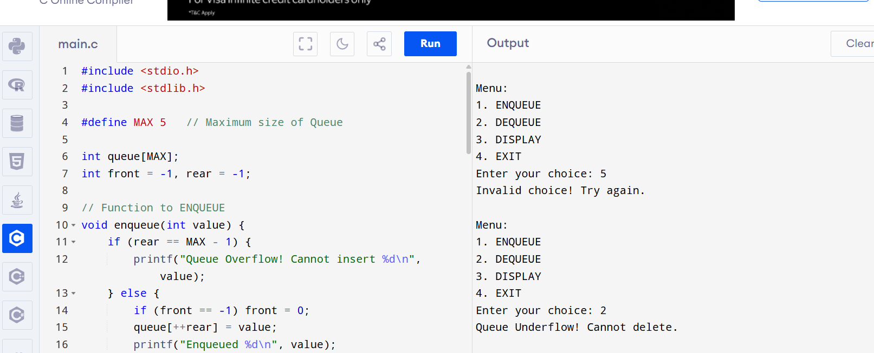

**OUTPUT:**

Menu:

1. ENQUEUE

2. DEQUEUE

3. DISPLAY

4. EXIT

Enter your choice: 5

Invalid choice! Try again.

Menu:

1. ENQUEUE

2. DEQUEUE

3. DISPLAY

4. EXIT

Enter your choice: 2

Queue Underflow! Cannot delete.